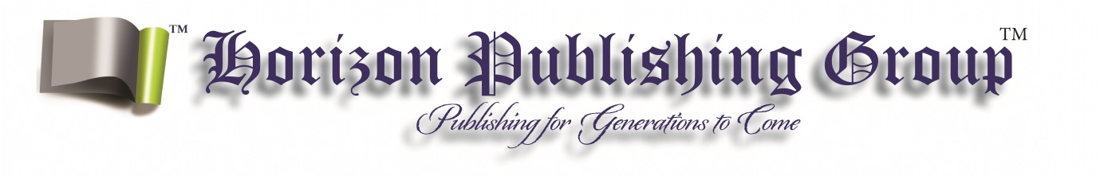
Payment Form/Tax invoice
2015/16 Horizon Publishing Group
Outstanding Literary Awards (HPGOLAS)
ABN: 39 470 232 972

Please complete clearly in block letters and send to HPG: hpgolas@horizonpg.net

Contact Name: ...........................................................................................................

Phone......................................................... Mobile: ....................................................

Email............................................................................................................................

Address (required)........................................................................................................

……………………………………………………………………………….

No. of entries: .................................................................. (inc gst) @ $99.00 per entry.

Total owing...................................................................................................................

Payment Method (please tick one) Cheque EFT

If paying by EFT:

- Bank: Commonwealth Bank
- BSB: 062-401
- Acc. No.: 10140779

Please email/send remittance advice with this form.

If paying by cheque, please complete and send this form with a cheque for the full amount made payable to Horizon Publishing Group: P.O. Box 275, Cherrybrook NSW 2126.

I have read and accepted the Terms and Conditions (please tick)

You must submit this payment form with your entries for them to be considered for judging. If payment is not received, your entries will not be judged.

